Name
Club Name
SYFA Club ID No

SYFA LIMITED (SYFA)

SYFA SELF-DECLARATION FORM

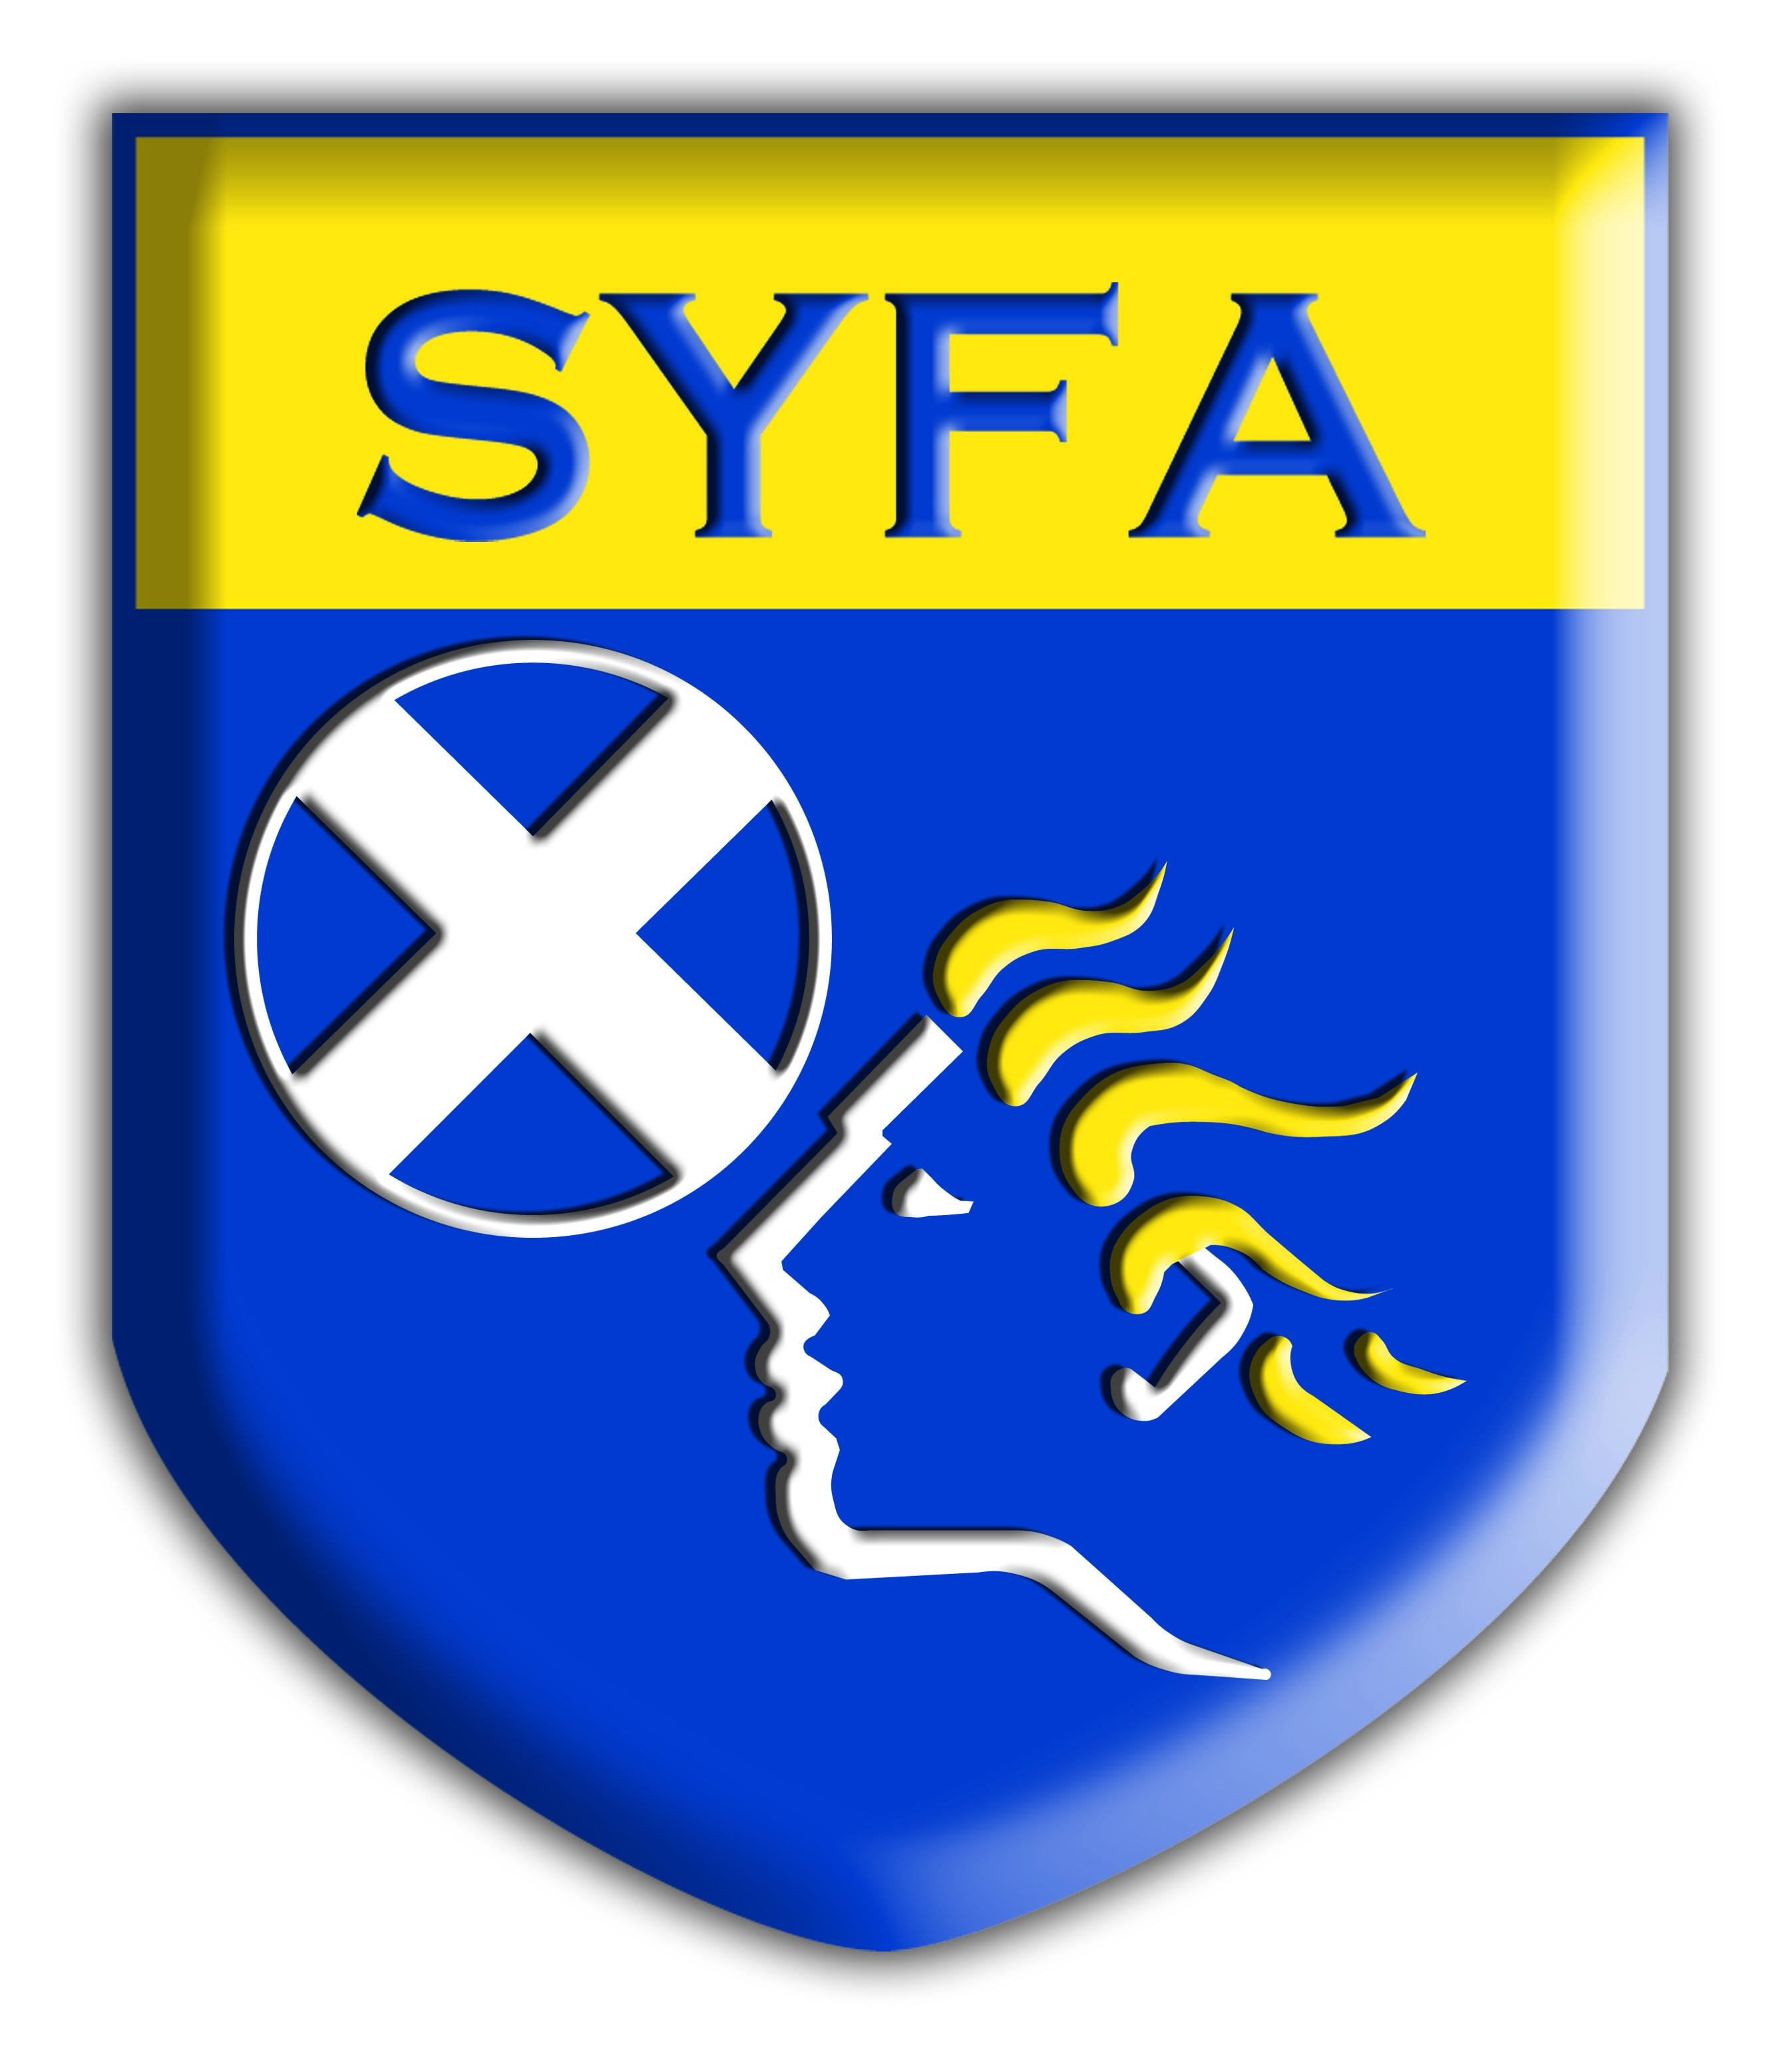

SYFA Limited (SYFA) Self-Declaration Form

Private and confidential

It is the policy of the SYFA that ALL applicants to posts that involve contact with players, young people and vulnerable adults MUST to complete an SYFA Self-Declaration Form. Before completing this form, please read the guidance notes which are included with this form.

Part A: Previous convictions.
MUST be completed by ALL volunteers seeking membership of the SYFA

Have you any conviction(s): YES/NO If NO, go to Part B, If YES, please give details.

Date(s) of conviction(s):

Court(s) where your conviction(s) were heard:

Type of offence(s):

Sentence(s) received

PLEASE GIVE FULL DESCRIPTION OF OFFENCE. If more than one offence please continue on a separate sheet of paper and attach to this Form.

Cont. over
Please give details of how you completed the sentence(s) imposed, (for example did you pay your fine(s) as required; what conditions were attached to your probation/community service/supervised attendance order(s), did you comply with the requirements of your custodial sentence(s).

Have any other organisations supported you to work through any of the above issues/difficulties?

What have you learned from your experience?

Part B – Details of any disciplinary action relating to behaviour to children, young people and vulnerable adults.
MUST be completed by ALL volunteers seeking membership of the Scottish Youth FA

Have you been disciplined because of inappropriate behaviour towards a child, young person or vulnerable adult which may have harmed them or put them at risk of harm? YES/NO

If NO, go to Part C. If YES, please give details.

Cont. over
Part C: Police Investigations – this should include relevant police non-conviction information.
MUST be completed by ALL volunteers seeking membership of the Scottish Youth FA

Have you been investigated by the police: YES/NO
If NO, go to Part D, If YES, please give details.

Date of investigation(s):

Police Division(s) involved:

Details of investigation(s)

Please give details of the reasons and circumstances that led to your investigation(s):

Disposal(s) if known:

Are you, or have you ever been, known to any Social Work Department/Social Services Department as an actual or potential risk to children or vulnerable adults?
YES/NO

If yes, please provide details

Cont. over
Part D: Protection of Vulnerable Groups (Scotland) Act 2007. Self-Declaration.

Before answering the question below, please read the following notes:

It is an offence for someone placed on the children’s list to do regulated work, or attempt to do regulated work, with children.

It is an offence for someone placed on the adults’ list to do regulated work, or attempt to do regulated work, with protected adults.

Penalties for individuals doing regulated work when barred
Any individual doing, or attempting to do, work from which they have been barred is committing an offence. On conviction on indictment the penalty is up to 5 years imprisonment and/or an unlimited fine.

Penalties for organisations offering regulated work to a barred individual
Organisations that employ barred individuals in regulated work with children or protected adults are committing an offence. It is also an offence for a personnel supplier to offer or supply a barred individual to an organisation. On conviction on indictment the penalty is up to 5 years imprisonment and/or an unlimited fine.
To help us ensure we are complying with the Protection of Vulnerable Groups (Scotland) Act 2007, please complete the following declaration.

I _____________________________________ [full name in block capitals]

Of [address] ______________________________________________

______________________________________________

Postcode ______________________________________________

Club Name: ___________________________________ Club SYFA ID No ________________

confirm that I am not listed under the Protection of Vulnerable Groups (Scotland) Act 2007

OR

I am the subject of a referral to Disclosure Scotland under the Protection of Vulnerable Groups (Scotland) Act 2007

I understand that deliberately giving false information can result in prosecution.

Signed _________________________________ Date ________________

Part E: Declaration
MUST be completed by ALL volunteers seeking membership of the Scottish Youth FA

I hereby declare and represent that, except for as disclosed above, I have not at any time, whether in the United Kingdom or abroad, been found guilty and sentenced by a court for a criminal offence.

I give my consent to The Scottish Youth FA carrying out a PVG Scheme check and to requesting references for the purposes of verifying the replies given in this declaration, including enquiries of any relevant authority.

I agree to inform The Scottish Youth FA if I am convicted of an offence after I take up any post within the organisation. I understand that failure to do so may lead to the immediate suspension of my work within the Scottish Youth FA and/or the termination of my services.

If I am appointed to a post, I agree to abide by the organisation’s Articles of Association, Supplementary & Playing Rules, Code of Conduct and ALL Protection Policies and Guidelines.

I agree to abide by the conditions above and certify that the information contained in this form is true and correct to the best of my knowledge. I realise that false information or willful omissions will lead to the immediate suspension of my work within the Scottish Youth FA or the termination of my services.

Signed: ______________________________________Date:____________________

All officials seeking membership of the SYFA MUST complete an SYFA Self-Declaration Form. A form can be downloaded from the SYFA website.

The SYFA National Protection Panel may instruct officials, at any time, to submit or resubmit a fully completed SYFA Self-Declaration Form.

All SYFA Self-Declaration Forms, where the answer to Part A, (have you any convictions), is YES, must be sent to the SYFA National Protection Officer at Scottish Youth FA, Hampden Park, Glasgow, G42 9BF within an envelope clearly marked PRIVATE AND CONFIDENTIAL.
The SYFA National Protection Panel will be the ONLY committee to view and/or use this SYFA Self- Declaration Form.

All SYFA Self-Declaration Forms, where the answer to Part A, (have you any convictions), is NO, must be sent to the SYFA Club’s Protection Officer and safely stored by the club. These forms should be available for viewing as part of the SYFA Monitoring Programme.

Please note that any information you give in this form will be managed in the strictest confidence and on a need to know basis. Your completed Self-Declaration Form will only be seen by the Chief Executive, SYFA National Protection Officer and/or the SYFA National Protection Panel.

Please read these notes before completing the Self-Declaration Form.

The information you give in this Self-Declaration Form will support the information we also obtain from your references and your PVG Scheme certificate. All of these sources of information will help us to make an informed decision about your application for membership.

Who must complete the Self-Declaration Form?
It is the policy of the Scottish Youth FA that ALL applicants for membership MUST complete a Self-Declaration Form.

The position that you are applying for is also exempt from the Rehabilitation of Offenders Act 1974 by the Exclusions and Exceptions (Scotland) Order 2003. You are therefore advised to declare all convictions including ‘spent’ convictions.

Which sections of the form must I complete?
As the Scottish Youth FA requires a PVG Scheme check you MUST complete Parts A, B, C, D and E of this form.
You must also provide identification so that the personal details you provide can be verified. You will be asked to provide identification when completing a PVG Scheme Form.

Who gets to read the Self-Declaration Form?
The Self-Declaration Form should be sent to us in a sealed envelope. Your completed Self-Declaration Form will only be seen by the Chief Executive, SYFA National Protection Officer and/or the SYFA National Protection Panel.

What happens to the Self-Declaration Form after a decision has been made on my application?
The Self-Declaration Form and the PVG Scheme Certificate will be retained by the Scottish Youth FA until a decision has been made on your application for membership. This information will not be kept any longer than required before being destroyed. We will not return information unless you request the information to be returned and provide a stamped self addressed return envelope.

What happens if I do not wish to complete a Self-Declaration Form?
In accordance with our Protection Policies ALL officials who do not submit a fully completed SYFA Self-Declaration Form will be debarred from membership. All officials who submit an SYFA Self-Declaration Form and provide false information and/or omit information will be debarred from membership.

Will any criminal conviction debar me from membership?

Offences listed under Schedule 1 of The Protection of Vulnerable Groups (Scotland) Act 2007 will definitely debar any person from membership.
Other offences will not debar people from seeking membership but will need to be referred to the SYFA National Protection Panel for their decision.

